SOLAR CYCLE UPDATE: Solar Cycle 25 continues to overperform. Sunspot counts for Sept. 2021 were the highest in more than 5 years. And, for the 11th month in a row, the sunspot number has significantly exceeded the official forecast.
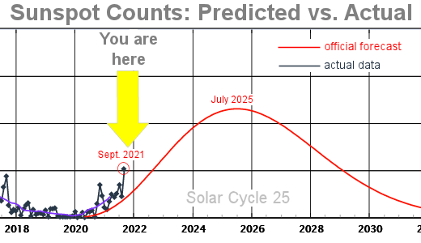
The plot above shows sunspot counts vs. time. The red curve traces the forecast issued by the NOAA/NASA Solar Cycle 25 Prediction Panel in 2019. It calls for a relatively weak solar cycle peaking in July 2025.
The sun has a mind of its own, though. Higher-than-expected sunspot counts suggest a stronger cycle, with a peak occurring in late 2024 instead of mid-2025. This is good news for aurora watchers, but maybe not so good for the Internet.
This is the address of the sight: just copy and paste if it does not link
https://spaceweather.com/

