Happy Sabbath to all!
Now that most of us have entered the 12th Biblical month there is a lot we will need to brush up on, for in this month we can have a lot of things happening which affect the upcoming end to winter and start to summer in the Land.
Events, which may or may not take place with a majority of the 10 Biblical witnesses are to be tracked very diligently the second half of this Gregorian month of February.
For instance: if we do not have at least one sustained sharav event (very hot/dry/east wind) during this month we have always had to add an intercalated month to the existing Biblical Year. That’s a fact, not fiction. And of course, we know who controls all the weather to bring about Their desired outcome.
Deuteronomy 11:10-12 For the land which you go to possess is not like the land of Egypt from which you have come, where you sowed your seed and watered it by foot as a vegetable garden; but the land which you cross over to possess is a land of hills and valleys, which drinks water from the rain of heaven, a land for which Yehovah/Yahweh your Elohim cares; the eyes of Yehovah/Yahweh your Elohim are always on it, from the beginning of the year to the very end of the year.
That is a very definitive statement. All the crops to be grown will be dependent upon our Elohim to make it happen for all the magnificent spiritual realities it encompasses. That is just one reason we follow the winter weather in Israel. It is our Elohim showing us He is in control of the associated growth cycle and its timing.
This was all common knowledge to Native Israel.
Jeremiah 5:24 They do not say in their hearts, let us now fear the Lord our God, who gives rain, both the former and the latter, in its season. He reserves for us the appointed weeks of the harvest.
Now, being students of the Bible and understand basic agricultural principles, we know this is talking about the barley harvest. Why?
Because it states the appointed weeks of the harvest. Only the barley has appointed weeks to harvest the entirety of the crop in, seven to be specific. You can search the scriptures from cover to cover and will not find a set period of weeks to the wheat harvest.
Please apply the spiritual ramifications to that one.
Amos 4:7 I also withheld rain from you when there were still three months to the harvest. I made it rain on one city, I withheld rain from another city. One part was rained upon, and where it did not rain that part withered.
Simple instruction here is our Elohim decides where and when it rains in the Land and thus where and when the crops will ripen. As strange as it may seem there are many locations which do not get enough rain to bring a grain crop to harvest. They are usually associated with rocky ground.
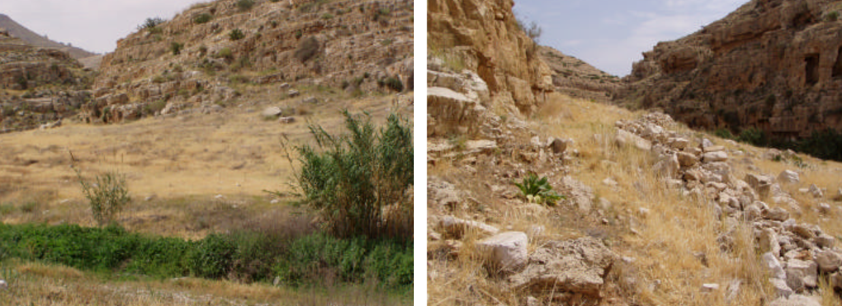
Many of you will recognize this location if you have been participating in the Abib Calendar wars over the years. It is Ein Mabu’a and it has been used to declare the start of the year by some who have influence over members in the Body of Christ/Messiah.
The wild barley that grows here is anemic at best for multiple reasons. The area receives a little amount of rain in the winter months which allows it to germinate and commence the growth cycle. Unfortunately, when the rain stops each of these little tiny anemic barley plants make a decision to put all their strength into producing a couple of seeds that will reach physiological maturity and thus the state of aviv. Thus, it has some hope of reproducing itself after the command in Genesis the first chapter. However, it is stunted anemic barley full of blemishes.
The other thing working against it is there is very little soil mixed amongst all the big rocks and little rocks.
Matthew 13:5-6 Some fell on stony places, where they did not have much earth; and they immediately sprang up because they had no depth of earth. But when the sun was up, they were scorched, and because they had no root they withered away.
This is a Biblical, agricultural, principle with spiritual realities to it which was taught to us by Christ/Messiah Himself. In spite of that we have and are mocked by some when we speak to its validity during our inspections. I am talking about people who profess to be in the Body.
Here are two more examples of this stony ground which produces anemic grain at best.
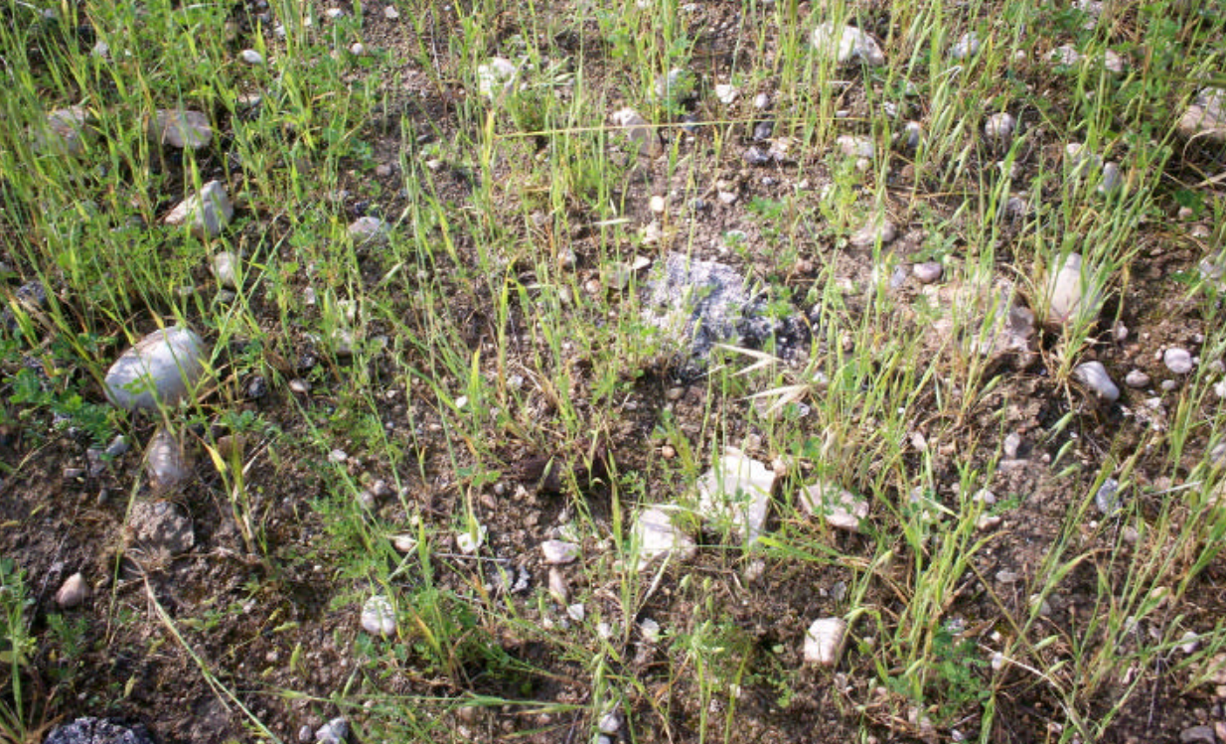
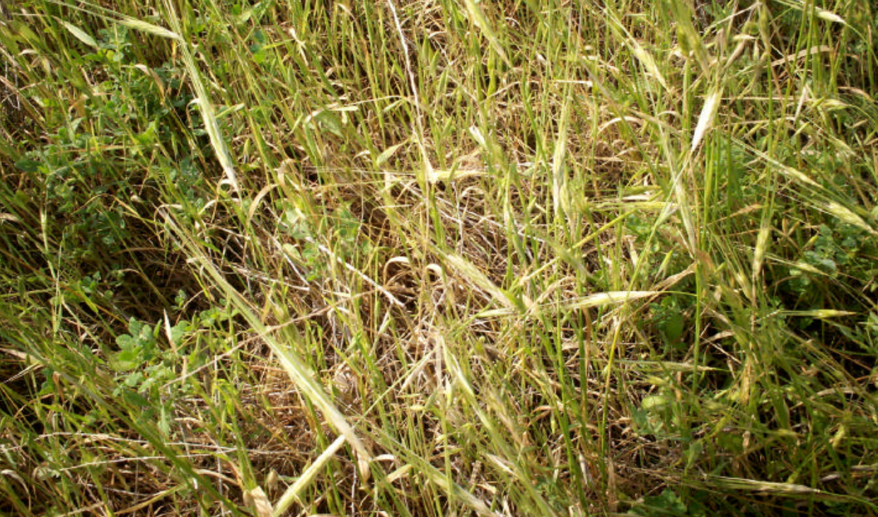
This is completely unacceptable barley to use for a wavesheaf offering so it can’t be used to declare the start of a Biblical Year. The Wavesheaf Offering is a holy offering and thus it is to be without blemish just as our Savior was spiritually. So please do not be deceived with barley being put forth as acceptable from bad soils.
As many of you know we emphasis that the barley must also come from good ground for multiple reasons to the point of being annoying to some. What is the Biblical definition of good ground?
Certainly not stony ground as we just read.
And certainly not that which is spoken about in:
Matthew 13:7 And some fell among thorns and the thorns sprang up and choked them.
That is the Creator speaking to us. Do we believe Him or not? Based on the past performance of many they didn’t in the past but hopefully do now. Its all a learning process, especially for those who have been detached from working the land and involvement in agriculture.
What does He say is good ground and what is the result of utilizing it?
Matthew 13:8 But others fell on good ground and yielded a crop: some a hundredfold, some sixty, some thirty.
You can only harvest a wavesheaf offering from a crop of grain from good ground! No exception because of what the physical harvest represents in spiritual realities to come.
What are the characteristics of good ground? That which could be worked with the implements of the day.
Isaiah 28:23-26 Give ear and here my voice, listen and here my speech. Does the plowman keep plowing all day to sow? Does he keep turning his soil and breaking the clods? When he has leveled its surface, does he not sow the black cummin and scatter the cummin, plant the wheat in rows, the barley in the appointed place, and the spelt in its place? For he instructs him in right judgment, his Elohim teaches him.
Here our Elohim is teaching us what good ground is, which is to be used to produce all the different grain crops. It needs to be able to have its soil turned with a plow. That means; wood and steel and oxen of the day. It had to be of such quality that it would break up after that and be able to be leveled to make it uniform and flat. Only then could these 4 species of grain be sown or planted in each of their own places and fashion.
We have seen a lot of pictures of wild and domestic grain so far this year which are very healthy looking, even those located in stony ground. The reason is the rain is still coming down and the plants are all flourishing. They are on their way to growing very fat and very tall. We have witnessed this pattern during many inspection years in the Land. As long as the rain keeps coming the plants will keep putting energy into big broad leaves and thick tall stalks. That’s a simple agricultural fact once again and not fiction. But, as soon as it stops those located in poor soils will change rapidly out of sequence with the rest of the land.
We have witnesses all too often where grain growing in questionable soil and little enough rain comes to maturity, but with all the flaws of anemic blemished unacceptable barley. The plant sacrifices most of its tillers if not all of them, and halts stem elongation for head production. Not all of the seeds in the head will reach aviv but some will. We see that happen a lot in the South.
This is what a healthy and acceptable head of wild barley looks like. It comes from good ground. The seeds are plump and well formed.
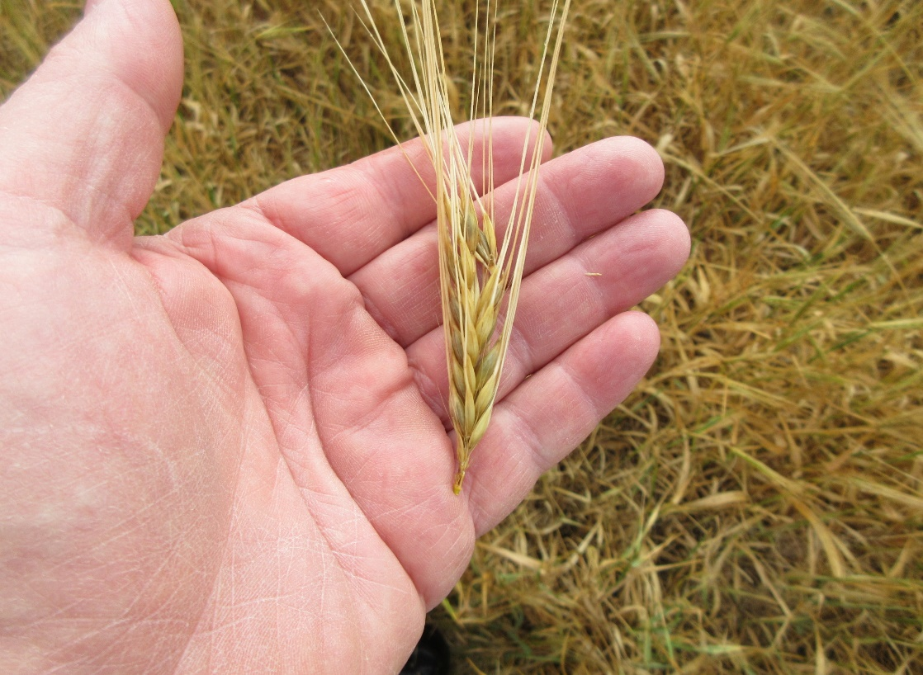
Then domestic six row, followed by domestic 2 row
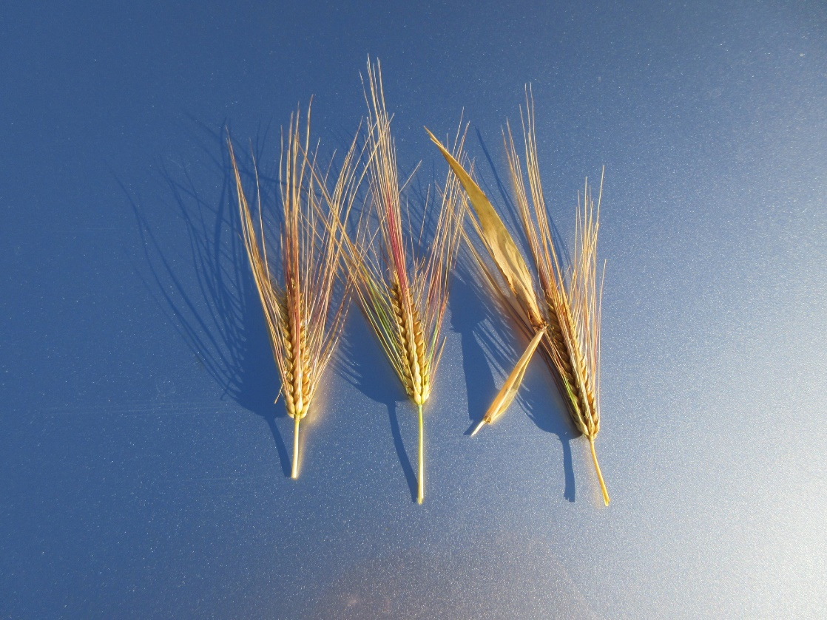
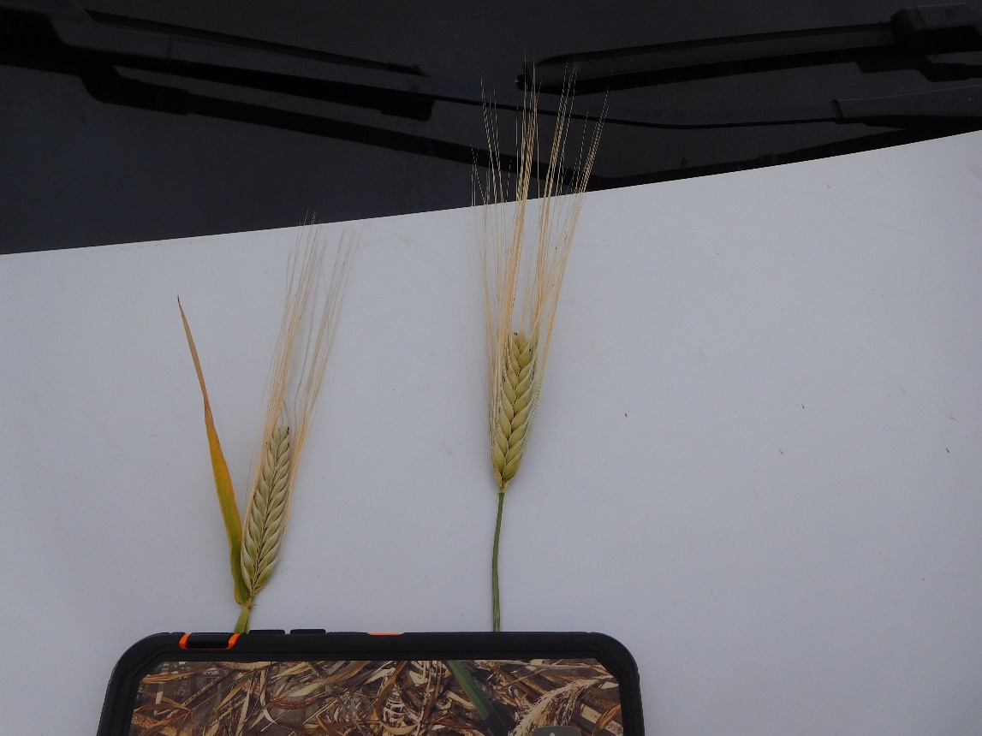
All of these are without blemish right out of the field. All have reached the state of Aviv, they are physiologically mature enough to reproduce themselves.
Another pattern we have witnesses often and reported on over the years is what takes place in the South and the Coastal Plain grain growing regions where the terrain is rolling hills. The grain at the top of the hill will always mature before that at the lower elevations of the same hill.
That can present a situation where you may find enough grain at the top of the hill, in random locations, which will be aviv, but surrounded by a sea of grain which is not. Remember we do not tip toe through the grain field picking a bouquet of grain stocks and trampling down all the younger plants to achieve a wavesheaf offering quota. Be aware.
That would destroy the entire spiritual reality it was to represent.
Here are 2 good examples of how this top of the hill maturing downward process takes place from past inspection trips.

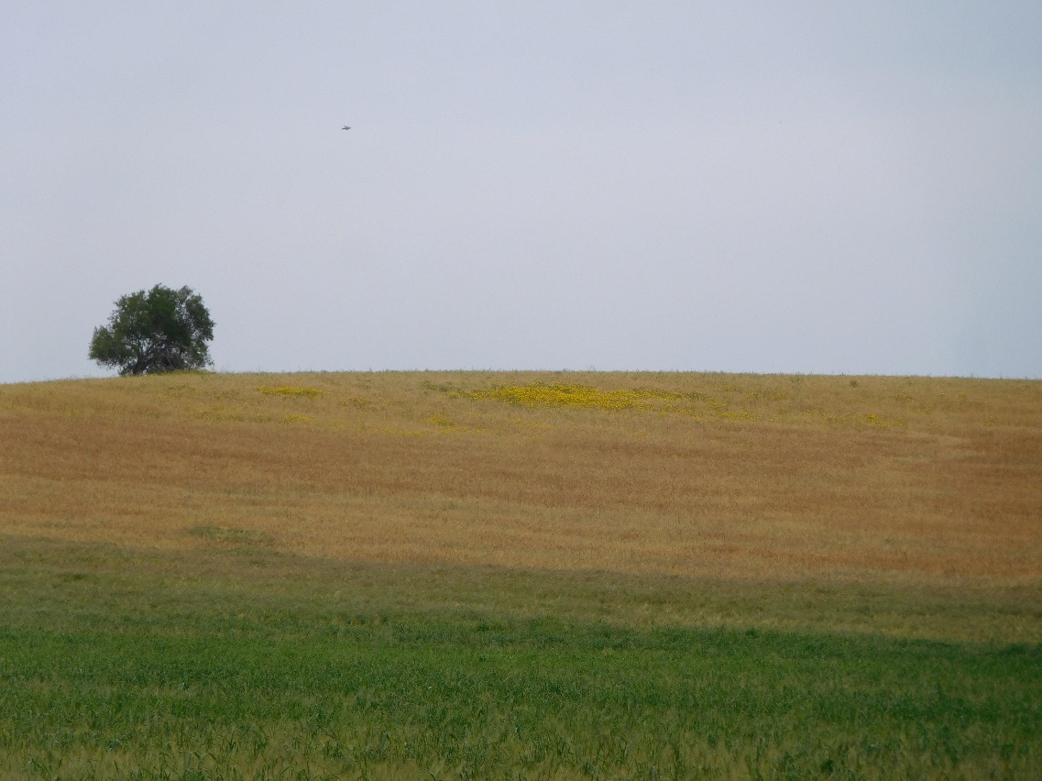

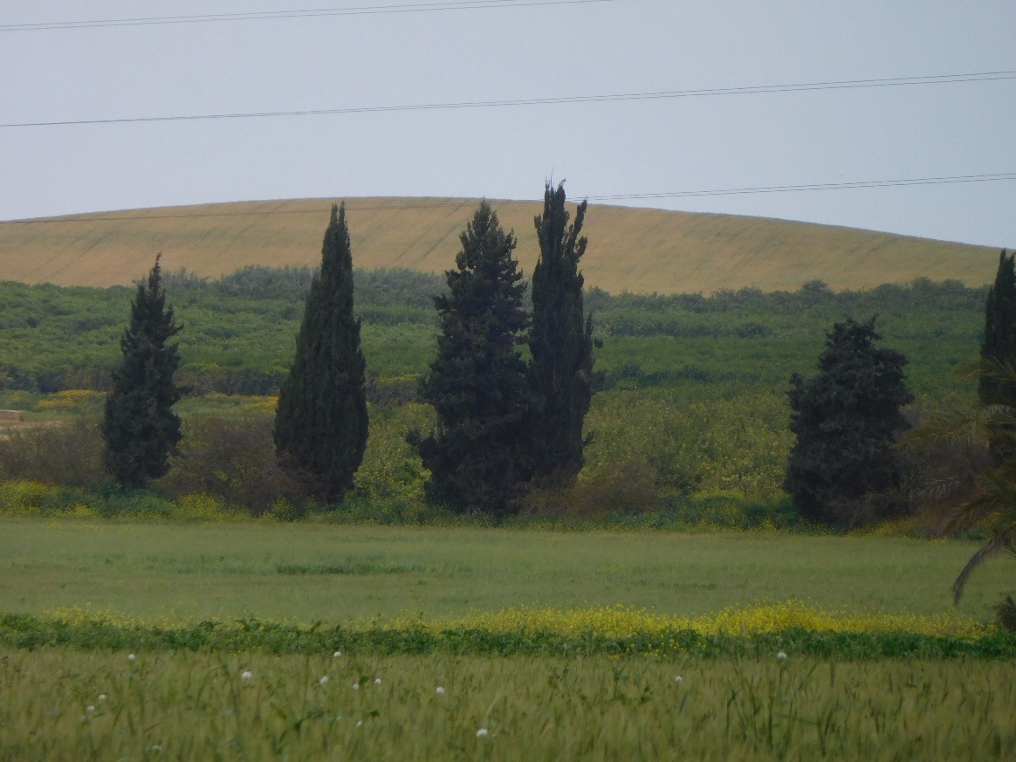
Notice the wild mustard growing in a ditch in the field. It too has its timing across the country at different elevations. While we are mentioning the flowers here is a picture of a species of yellow flowers that comes after the reign of the red anemones. In this photo notice the age of the wild oats and their dried-out husks empty of seed. The wild barley has reached aviv and is bowing to its Creator. Also notice the uniformity to this changing field of wild barley and wild oats.
This is an area around Re’im Junction that gets good rain in some years and in others not so good. It was a good year in this picture. Unfortunately, this year the area here down to Besor has been lacking rain. But to the north of it there has now been normal amounts with this previous winter storm. We will see later this month if it can measure up to an acceptable standard for a Wavesheaf offering at a future date. We will keep you posted on that one.
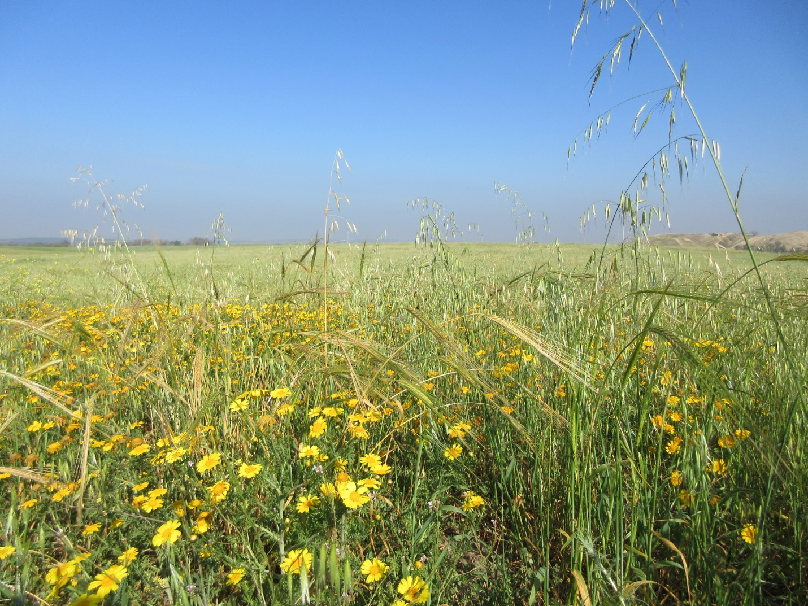

Below we have a classic picture of what we look for to display what good ground is. Here you have a field that has, for the most part, reseeded itself from the previous year or even years.
You can see wild oats towering above everything else in it. They are dried out husks having already dropped their seed weeks earlier. There is also wheat, domestic barley and wild barley here as well, all maturing at approximately the same time in this very good ground. There is a very big lesson in this for us all who follow the Abib Calendar.
In all but 2 of the years we have inspected in the Land, the domestic barley and the wild barley found in good ground have been aviv at the very same time. And yes, the wheat also to those who scoff at us for reporting on wheat for some folks who wish us too. This is winter wheat and not spring wheat. If they even know the difference between the two.
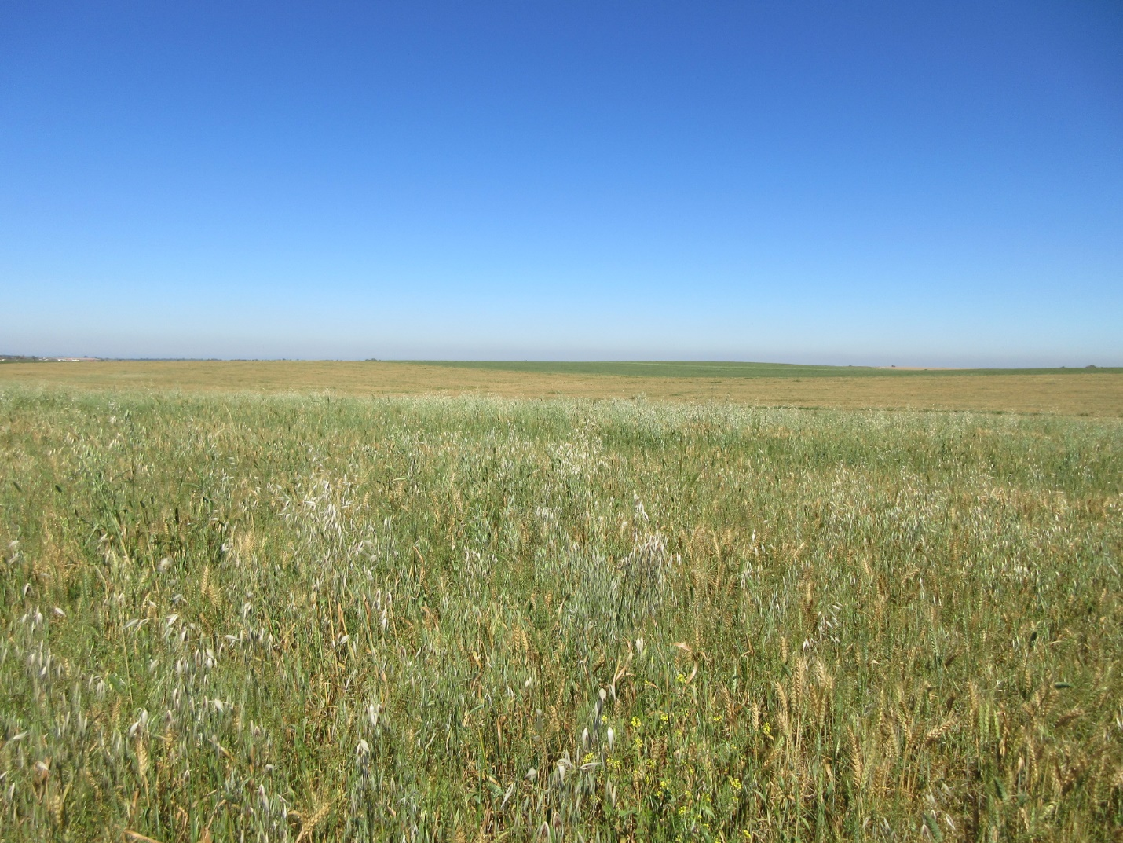

Here is a close up of that field.
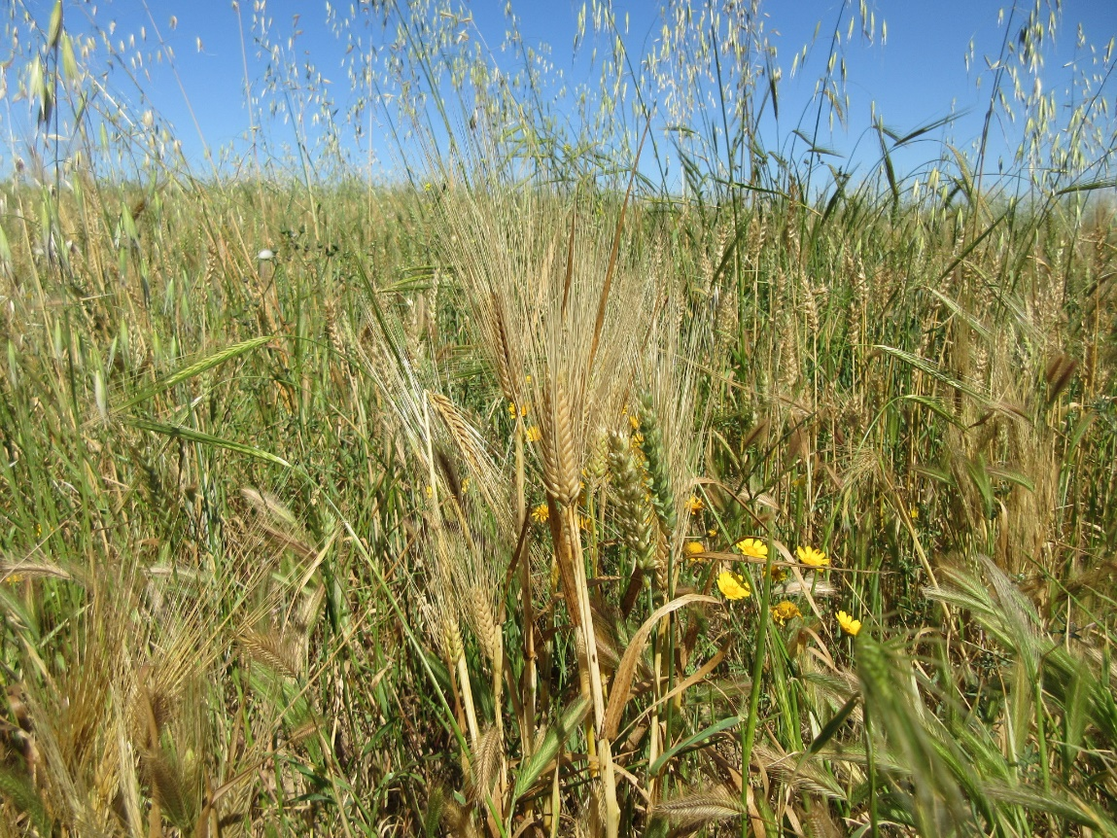
Now with this all behind us we will share a photo from Evgeny from yesterday in the Upper Jordan Valley.
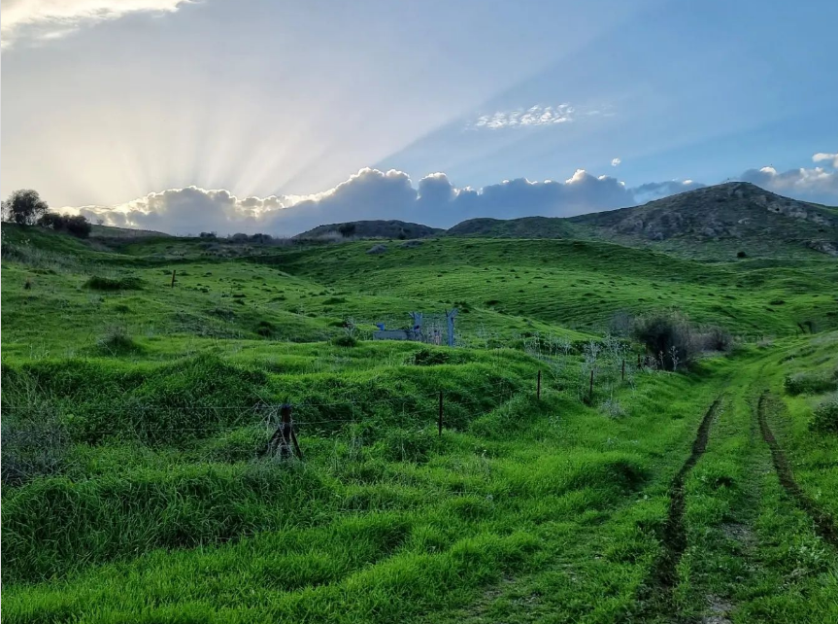
Such a beautiful picture of the current condition of the wild oats and wild barley in the middle portions of the country. This brilliant winter green is quite captivating with the sun just behind the horizon. But, lets get past that and look at the details.
Zoom in if you can. No stocks present, but very lush green tillers with nice leaf development. This is 50 to 60 days from being aviv if things go right. Just as it should be with the meteorological pattern for this cycle.
As pastoral as it all looks, it is completely unacceptable ground for a wavesheaf offering. It is pasture land, not grain growing land as defined by our Creator and his prophets.
Once again, we need to address the Abib Calendar through the eyes of our Elohim. Do not be defrauded of your crown. Fight the good fight.
If you would like to see any specific pictures of the grain from years gone by just let us know and we will try to provide them here on the site. Use the email provided to make your request.
Happy Sabbath to all and our Peace we give to you.

